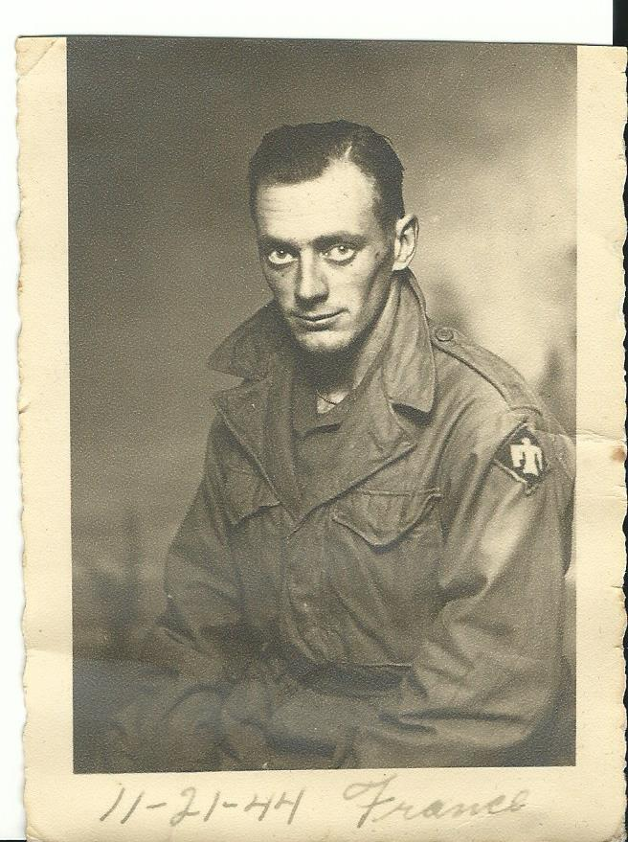

Photos from Glen Haskell Scrapbook II

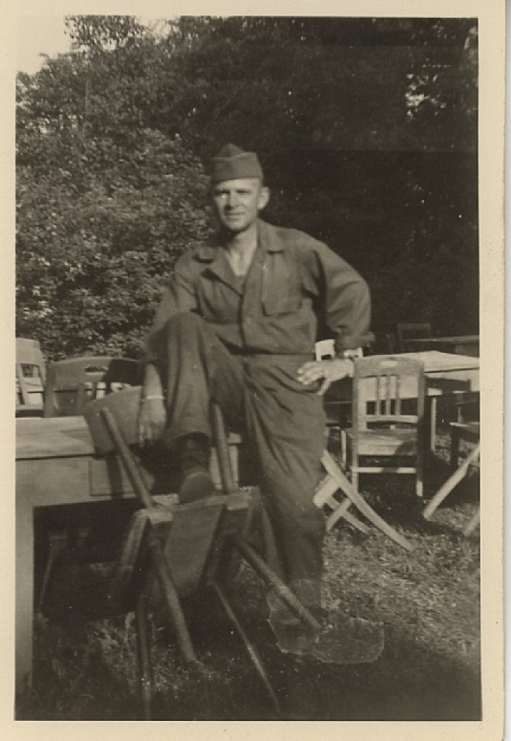Howard James, Munchen, Germany May 1945
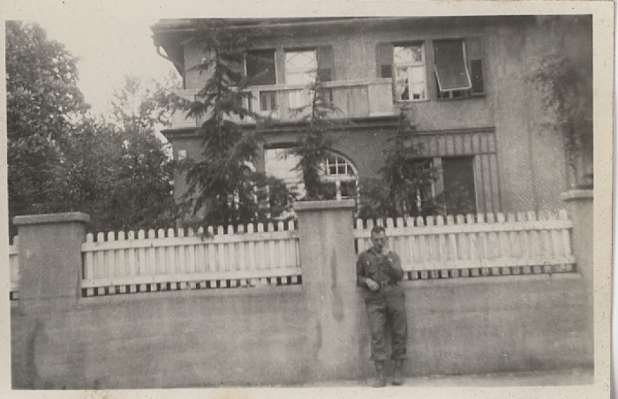Glen Haskell, Munich, Germany, May 1945 The house in the background is one we were living in for a while. One of the few our bombers left standing.
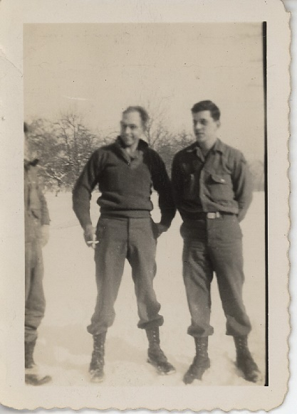McKenize and Capuizze and my pipe (Glen Haskell) on the German border in January, 1945

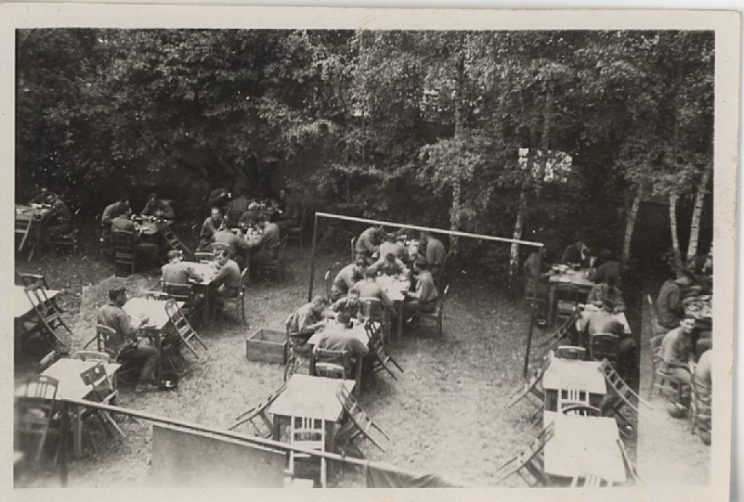Birds eye view of our mess hall at Munchen, Germany, May, 1945

