Photos from Glen Haskell scrapbook

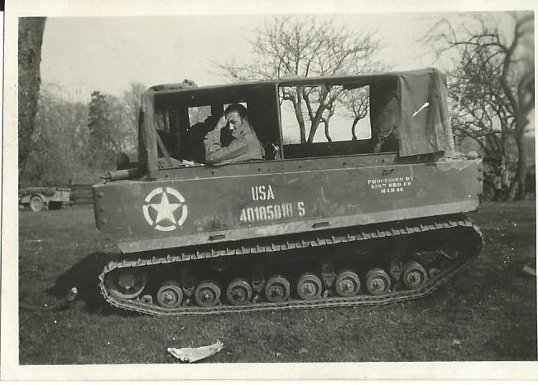 Glendene Hardin, Outside of Munchen Germany, May 1945

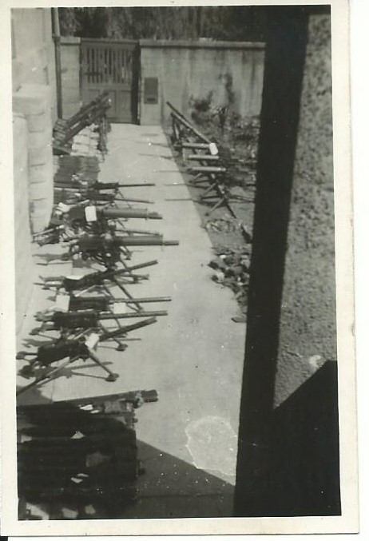Guns ready for Ordnance inspection in Munchen, Germany, May 1945

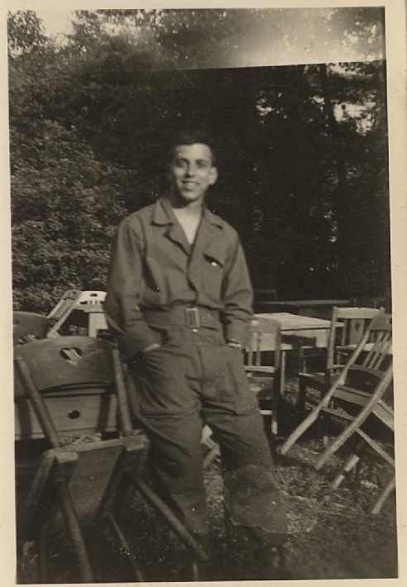 Our mail Clerk (Capuizze) in Munchen, Germany, May 1945

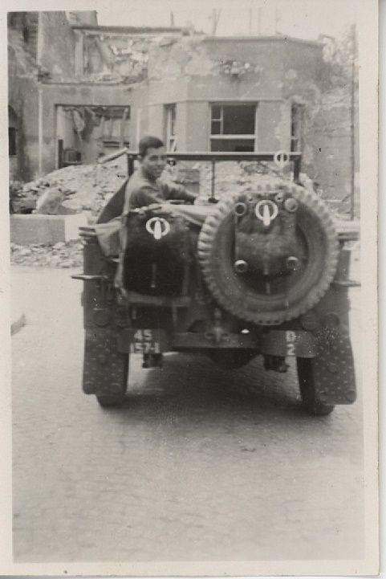 Munich Germany, May 1945, Mail clerk (note Jeep markings)

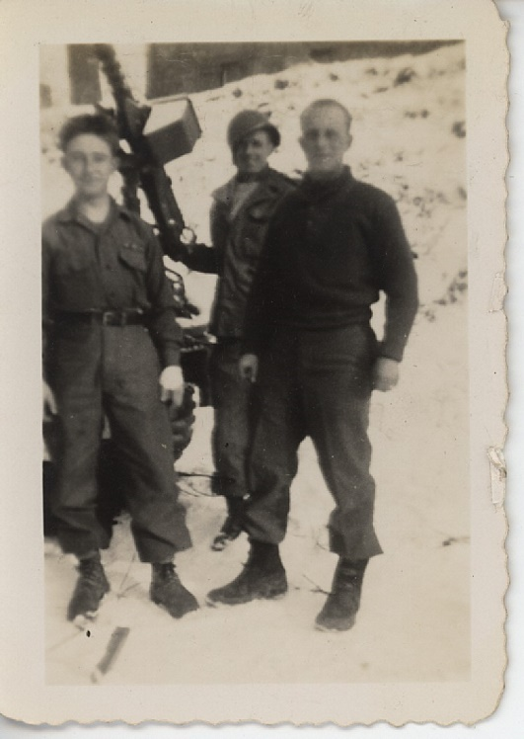 Gum, Kunsta, and Frienchie on the German border in January, 1945

